**PIZZA QUERIES**

**1.Total Revenue**

select sum(total_price) as Total_Revenue from pizza_sales;

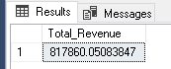

**2.Average Order Value**

select sum(total_price)/count(distinct order_id) as Avg_Order_Value from pizza_sales;

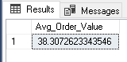

**3.Total Pizza Sold**

select sum(quantity) as Total_pizza_Sold from pizza_sales;

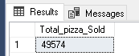

**4.Total Orders**

select count(distinct order_id) as Total_orders from pizza_sales;

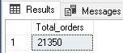

**5.Average pizza per order**

select sum(quantity)/count(distinct order_id) from pizza sales; 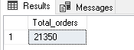

#The abouve query will give result without decimals to get decimal we can use cast () function

select cast(sum(quantity) as decimal(10,2))/

cast(count(distinct order_id) as decimal(10,2)) as Average_Pizza_per_order from pizza_sales;

#The DECIMAL(10,2) means we will get 10 decimal places among them up to 2 will be printed and in the result of this query the entire answer is not in casted

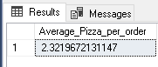

# To get this for entire result we can use/updtae query like

select cast(cast(sum(quantity) as decimal(10,2))/

cast(count(distinct order_id) as decimal(10,2)) as decimal(10,2)) as Average_Pizza_per_order from pizza_sales;

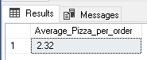

**7.Daily Trend of Order**

**DATENAME(DW,order_date)-DATENAME is a function to retreve date its argument is DW(date of Week it retrives date of week as character string**

select DATENAME(DW,order_date) as order_day, count(distinct order_id) as Total_orders

from pizza_sales

group by DATENAME(DW,order_date);

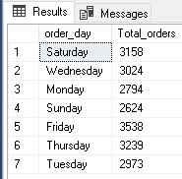

**8.Monthly trend of orders(we can find which is the peak month in which the most orders been placed).**

select DATENAME(MONTH,order_date) as Month_Name, count(distinct order_id) as Total_orders

from pizza_sales

group by DATENAME(MONTH,order_date)

order by Total_orders desc;

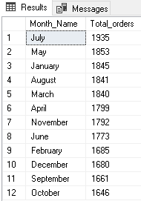

**9.percentage of sales by pizza category**SELECT pizza_category, CAST(SUM(total_price) AS DECIMAL(10,2)) as total_revenue,

CAST(SUM(total_price) * 100 / (SELECT SUM(total_price) from pizza_sales) AS DECIMAL(10,2)) AS PCT

FROM pizza_sales

GROUP BY pizza_category;

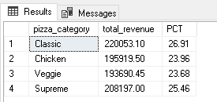

**10.percentge of sales by pizza size.**

SELECT pizza_size, CAST(SUM(total_price) AS DECIMAL(10,2)) as total_revenue,

CAST(SUM(total_price) * 100 / (SELECT SUM(total_price) from pizza_sales) AS DECIMAL(10,2)) AS PC

FROM pizza_sales

GROUP BY pizza_size

ORDER BY pizza_size;

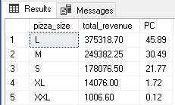

11.Total PIZZA sold by category

SELECT pizza_category, SUM(quantity) as Total_Quantity_Sold

FROM pizza_sales

WHERE MONTH(order_date) = 2

GROUP BY pizza_category

ORDER BY Total_Quantity_Sold DESC;

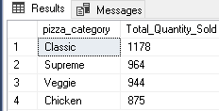

12. Top 5 Pizza by Revenue

select Top 5 pizza_name, sum(total_price) as TOTAL_REVENUE from pizza_sales

group by pizza_name

order by Total_Revenue desc;

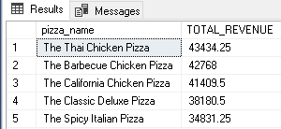

13. Bottom 5 pizza by Revenue

select Top 5 pizza_name, sum(total_price) as TOTAL_REVENUE from pizza_sales

group by pizza_name

order by Total_Revenue asc;

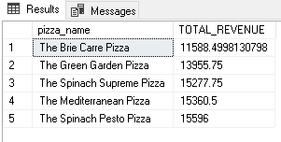

14.Top 5 pizza by Quantity

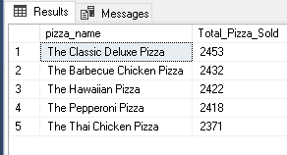

15.bottom 5 Pizza by Quantity

SELECT Top 5 pizza_name, SUM(quantity) AS Total_Pizza_Sold

FROM pizza_sales

GROUP BY pizza_name

ORDER BY Total_Pizza_Sold ASC;

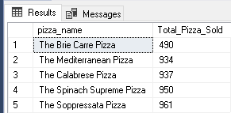

16.Top 5 by total orders.

SELECT Top 5 pizza_name, COUNT(DISTINCT order_id) AS Total_Orders

FROM pizza_sales

GROUP BY pizza_name

ORDER BY Total_Orders DESC;

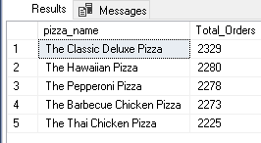

17.Bottom 5 by orders

SELECT Top 5 pizza_name, COUNT(DISTINCT order_id) AS Total_Orders

FROM pizza_sales

GROUP BY pizza_name

ORDER BY Total_Orders ASC

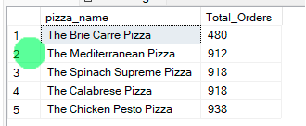

If you want to apply the pizza_category or pizza_size filters to the above queries you can use WHERE clause. Follow some of below examples

SELECT Top 5 pizza_name, COUNT(DISTINCT order_id) AS Total_Orders

FROM pizza_sales

WHERE pizza_category = 'Classic'

GROUP BY pizza_name

ORDER BY Total_Orders ASC